**A Web Search Engine – A Turf Booking Platform.**

A project report submitted in partial fulfillment

of the requirements for the degree of

**Bachelor of Engineering**

**In**

**Electronics and Computer Science**

by

**Ratan Singh (Roll No.: - 9511)**

**Aarush Wasnik (Roll No.: - 9517)**

Under the guidance of

**Prof. Archana Lopes**

**(Assistant Professor)**



DEPARTMENT OF COMPUTER ENGINEERING

**Fr. Conceicao Rodrigues College of Engineering, Bandra (W),**

**Mumbai – 400050**

**University of Mumbai (2022-23)**

**Internal Approval Sheet**

**CERTIFICATE**

This is to certify that the project entitled **" A Web Search Engine – A Turf Booking Platform "** is a bonafide work of **Ratan Singh (Roll no.: - 9511), Aarush Wasnik (Roll no.: - 9511)** submitted to the University of Mumbai in partial fulfillment of the requirement for the award of the degree of Bachelor in **Electronics and** **Computer Science.**

Prof. Archana Lopes

Supervisor/Guide

Prof. Sapna Prabhu

Head of Department

Dr. Surendra Singh Rathod

Principal

**Approval Sheet**

**Project Report Approval**

This project report entitled project **" A Web Search Engine – A Turf Booking Platform "** by **Ratan Singh and Aarush Wasnik** is approved for the degree of Bachelor of Engineering in Electronic and Computer Science.

Examiner 1. ————————————–

Examiner 2. ————————————–

Date:

Place:

**Declaration**

We declare that this written submission represents our ideas in our own words and where others’ ideas or words have been included, we have adequately cited and referenced the original sources. We also declare that we have adhered to all principles of academic honesty and integrity and have not misrepresented or fabricated or falsified any idea/data/fact/source in my submission. We understand that any violation of the above will be cause for disciplinary action by the Institute and can also evoke penal action from the sources which have thus not been properly cited or from whom proper permission has not been taken when needed.

Ratan Singh (Roll No.: - 9511)

Aarush Wasnik (Roll No.: - 9517)  **___**

Date:

Place: Mumbai

# Abstract

# In this rapidly developing world, the area available for outdoor activities has been reducing day by day. So, people prefer to book a turf. But the main problem faced by the sports enthusiast is that they don’t have enough resources or a single website where they can browse and book their favorite and best-offered deal to them without doing any manual work for a longer duration of time. So, we decided to build a search engine that will be specifically used for sorting turf with their need.

# The basic functionality of the search engine is that we need to input the engine with the name of the turf or the location of the turf with the price range. Then the search engine will display the most accurate result by using a sorting algorithm with condition term frequency. Then the user will click on the most satisfactory result and book the turf. The development system uses HTML, CSS, NodeJS, and ExpressJs.

# The search engine successfully solves the problems and is been executed successfully.

**Acknowledgments**

We have great pleasure in presenting the report on **" A Web Search Engine – A Turf Booking Platform "**. I take this opportunity to express my sincere thanks to the guide Prof. Archana Lopes C.R.C.E, Bandra (W), Mumbai, for providing the technical guidelines, and suggestions regarding the line of this work. We enjoyed discussing the work progress with him during our visits to the department.

We thank Dr. Sapna Prabhu, Head of the Electronics and Computer Science department, Principal, and the management of C.R.C.E., Mumbai for encouraging and providing the necessary infrastructure for pursuing the project.

We also thank all non-teaching staff for their valuable support, to complete our project.

Ratan Singh (9511)

Aarush Wasnik (9517)

Date:

**Contents**

**Abstract iv**

1. **Introduction 1**
   1. Motivation 2
   2. Objectives 2
2. **Literature Review 3**
   1. Title: Online Playground Booking System 3
   2. Title: Design and Implementation of Online Booking System of

University Sports Venue 3

* 1. Title: Design Of Web-based Information And Booking System for Futsal Field

Rental Business 4

1. **Problem Statement 5**
   1. Drawbacks of Current Sports Resource Management System 5
   2. Solution To Above Problem 5
2. **Project Description 6**
   1. Overview of the project 6
   2. E-R Diagram 7
3. **Implementation Details 8**
   1. Methodology 8
4. **Conclusion And Future Enhancements 9**
   * 1. Conclusion 9
     2. Future Enhancements 9

**References 10**

# List of Figures

4.1 Artificial Turf Market 6

4.2 Entity-Relationship Diagram for Search Engine 7

5.1 Working of a Search Engine 8

# List of Tables

2.1 Comparison of Research Papers 4

# 

**Chapter 1**

**Introduction**

In this rapidly developing world, the area available for outdoor activities has been reducing day-by-day or another option available for people is to book a turf for a limited period. Also, in the public open ground, there are more chances of getting restricted in a particular area or there might be disputes taking place among the people. So, nowadays people prefer to play on turf rather than on the open ground. But the problem faced by the user/people is that they don’t have enough resources or a single platform where they can browse and book the turf with the best deal without doing any manual work for a long period. So, we decided to develop a web search engine that will provide all the required services to the user.

The main characteristic of our platform is that it is not a website designed for turf booking but it’s a web search engine that will be hosting all the best deals available on that particular turf. It will sort all the turf with the best deal within the selected price range with most of the amenities and services and also based on ratings given to the turf and their location.

## **Motivation**

1. One stop platform where user can find the satisfactory output from the search engine.
2. Rising demand for the turf, but no application where user can compare the turf in term of space, price, ratings.
3. Global Artificial Turf Market 2021-2025: - The analyst has been Monitoring the artificial grass turf market and it is poised to grow by Rs 104 crore during 2021-25 progressing at the CAGR of over 5.45% during the forecast period.

**1.1 Artificial Turf Market**

## **Objectives**

1. To allow users to search and view information about Turf online using our search engine.
2. Using various filters (such as rating, amenities, and price range) as keywords to find the most accurate search result.
3. Using a sorting algorithm with condition term frequency of filter keyword.

**Chapter 2**

**Literature Review**

## **Title:** **Online Playground Booking System**

**Abstract:**

Every playground in colleges or schools may not have the capacity to include many students at a time, also can’t play more than one game at a time. This causes many problems like congestion and leads to the expelling of deserving people from playing. Also people from far away may lose their time and opportunity for playing the game.

Thus we propose a system for booking the playground online. By this system the players can book the ground online in favour with the session he wish to play .The user have to make a payment for booking the slot.The user’s presence at the ground can be identified by QR code scanning method.This system will make a fair situation and avoid unwanted problems.

* 1. **Title: Design and Implementation of Online Booking System of University Sports Venue**

**Abstract:**

To solve the imbalanced use of university sports venues, the online booking system of university sports venues based on the table tennis hall of Zhengzhou University is designed, combining the experience of the existing online booking systems, the main methods and the major ideal of building these systems both at home and aboard.

The basic functions of the system are designed according to the general requirement analysis, including user’s registration and login, online venue booking, online payment, personal center, message board and database construction. The development of the system used Java programming language, JSP (a Web platform development technology), MySQL database processing technology, JDBC data access model, MyEclipse development platform and Tomcat server. The system has accomplished such functions as online booking, online payment and online message. The tests of the system are run in good conditions.

The use of the system has made up for the current luck of sports venues management, solved the problems of the online booking function of university sports venues, improved the efficiency of the venues, and meet the needs for efficient use of the venues. The system can be an experience of the management of other college sports venues.

* 1. **Title: Design of Web-based Information and Booking System for Futsal Field Rental Business**

**Abstract:**

Limited free space for doing sports makes a lot of leased sports facilities, including a futsal field. Nowadays, if someone wants to rent a futsal field, a customer should make a reservation manually by going to the location or calling the manager. This research tries to offer a solution in the form of web design for the owners of futsal field rental businesses. The designed website will provide registration services for field owners to promote their field to potential customers. The web will display information on several futsal fields that have registered in the form of location, schedule with its booking list, and order procedure so that prospective customers could choose and place their order according to desired field and time. The web also features field location maps using google maps so that prospective buyer could know the exact location of each futsal field and the possible routes to the location. This information system has been tested on several computers and mobile phones connected to the internet. The testing result shows that this website has a responsive appearance. The site will adjust to the screen size when accessing devices with various specifications. The time delay in displaying a webpage depends on the quality of the network and the Android version of the device used.

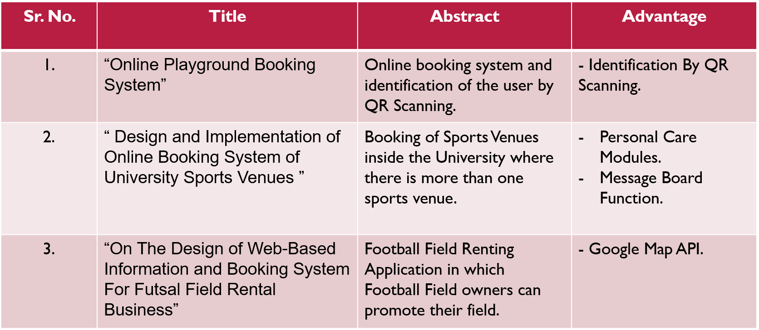**2.1 Comparison of Research Papers**

**Chapter 3**

**Problem Statement**

## **Drawbacks of Current Sports Resource Management System**

Users are not able to avail the best-sorted deals according to their needs and pocket size at a one-stop platform.

In this rapidly developing world, the area available for outdoor activities has been reducing day by day. So, people prefer to book a play inside the turf. But the main problem faced by the sports enthusiast is that they don’t have enough resources or a single website where they can browse and book their favorite and best-offered deal to them without doing any manual work for a longer duration of time. So, we decided to build a search engine that will be specifically used for sorting turf with their need.

## **Solution To Above Problem**

1. The facility of a Search Engine for specifically booking a playground is not available in the current area of the turf booking system.
2. A search engine with various filters will help find accurate results based on the need in terms of price, location, and amenities.
3. An application that will sort all the existing websites of turf and will show the best deal for the user.

**Chapter 4**

**Project Description**

## **Overview of the project**

**Area:** - SportsResource Management System.

**PURPOSE**: - This study aims to design a web search engine for Turf Booking to evaluate the best deal for the users while booking their turf along with other add-ons. Thus, it becomes a one-stop Platform where users can compare and select the most satisfactory deal for them.

**DESIGN**: - We will be using simple web development languages to build the web search engine which will perform reliability analysis to get the best deal with the help of measurable scales such as rating, amenities, price range, chatbot, and much more. We will be using Html and CSS for the frontend development of the search engine and the backend part, we will be using Node JS i.e., Xpress JS for the framework.

**ORIGINALITY**: - This is one of the first web engines that analyses the input resources and sorts using algorithms and displays the required output especially used for turf booking.

**4.2** **E-R Diagram**

The Entity – Relationship Diagram for the Web Search Engine is given below: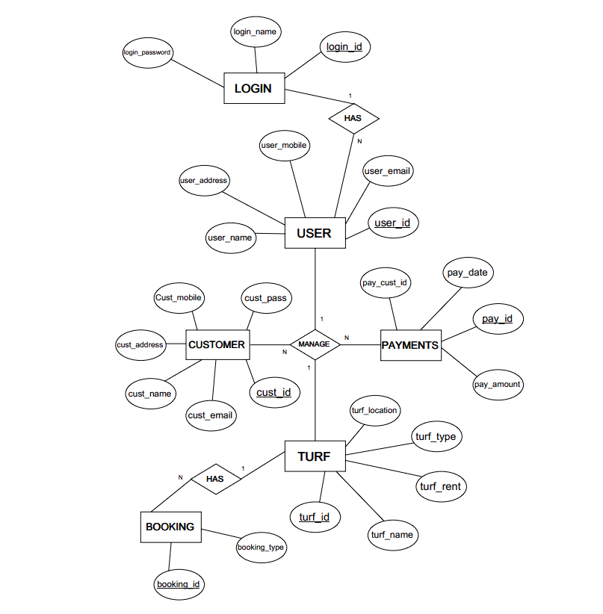

**Chapter 5**

**Implementation Details**

## **5.1 Methodology**

T**he Search Engine works in the following Steps: -**

1. Input (Query) from User.
2. Crawl 🡪Web Spider.
3. Index.
4. Ranking Algorithm.
5. Shows Output.

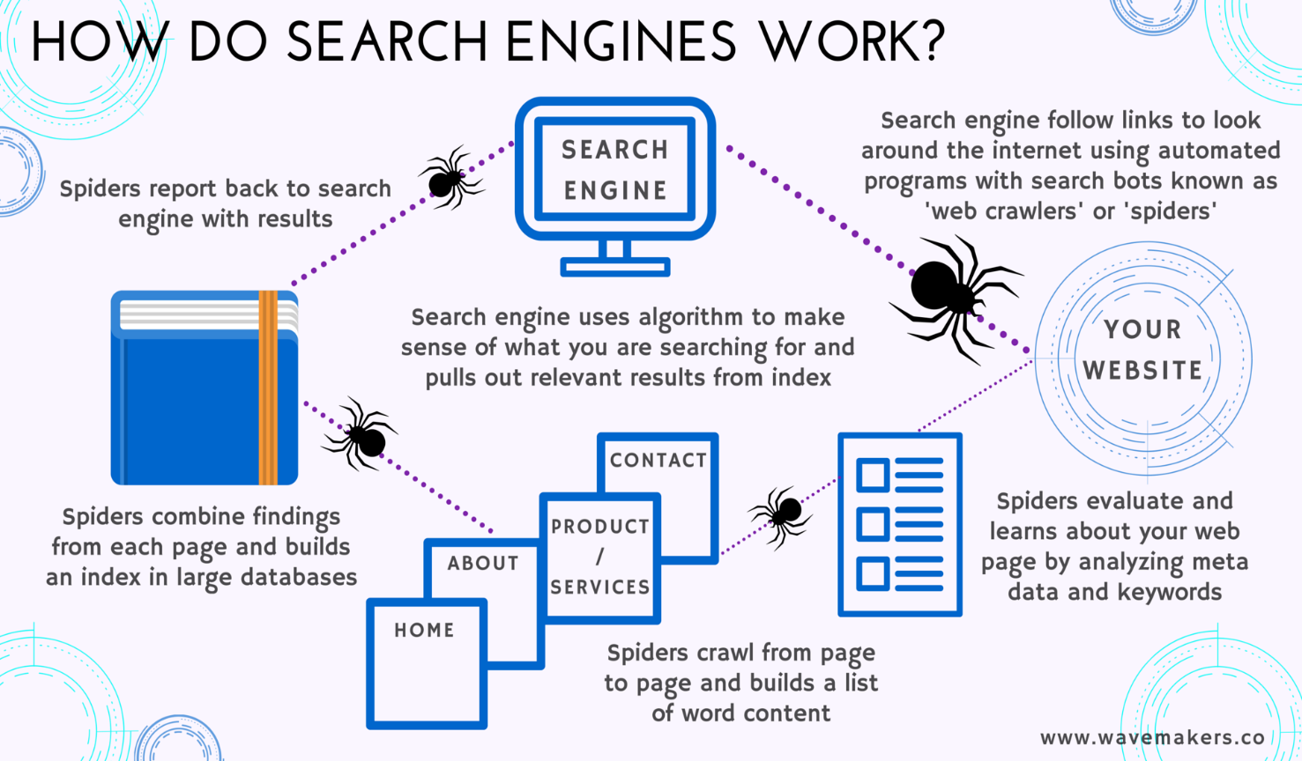

**5.1 Working of a Search Engine**

**Chapter 6**

**Conclusion And Future Enhancements**

### **Conclusion**

The use of the system can be made up for the current lack of sports venue management.

It can solve the problems of the online booking function of sports venues.

It can improve the efficiency of the venues and meet the needs for efficient use of the venues.

In this study, there are a lot of shortcomings.

### **Future Enhancements**

It will provide recommendations for the availability of the turf at a cheap price with short intervals of time from search time.

# References

**Resources: -**

1. Google Scholar.
2. Web Technologies used by Trivago.be (w3techs.com).
3. YouTube.
4. GeeksforGeeks.

**Research Paper: -**

**[**1] Michael M. Beveira, Sandra Jeyes C, Vishnu V. Online Playground Booking System. C CO - nihb.ac.in

[2] Can Li, Junjie Li, Hongxiang Cao, and Zhan Meng. Design and implementation of online booking system of university sports venues. MATEC Web of Conferences, 100:02024, 01 2017.

[3] Moechammad Sarosa, Verda Nurohmansah, Wahyu Permana, and Yoyok Heru. On the design of web-based information and booking system for futsal field rental business. International Journal of Computer Applications Technology and Research, 7:225–230, 06 2018